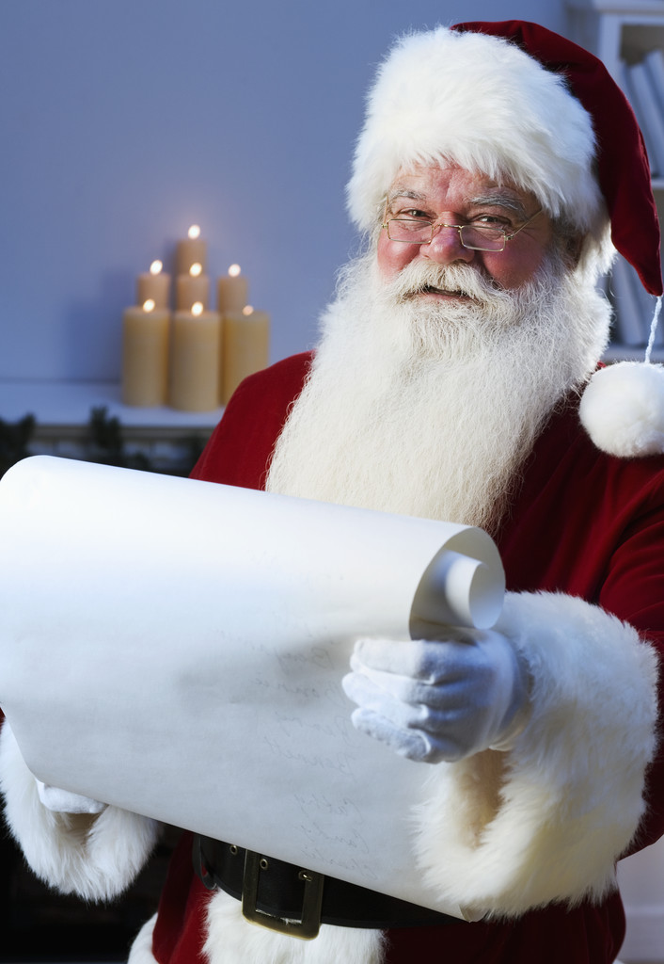

Pictures with Santa and
a store super sale, December 15,
SATURDAY 10am-noon

RSVP to get on Santa’s List if you are
an FCAOC licensed foster parent member!
One photo per family at no charge
+ gifts as available to those who
RSVP by calling 778-3383.
ALL are welcome to have their
Picture taken with Santa for a small
fee as time permits.
Bring your Friends & Family!
Santa will be handing out gifts while they last for all who visit and get a photo.
333 S. Brookhurst
Anaheim
714 778-3383

